

Organizational Behavior

Course Summary

Marc Delingat

delingat@yahoo.com
http://www.geocities.com/delingat

Module 6: Understanding Work Group Dynamics and Group-Based Problem Solving

Group Structure and Definition
A group within the organization is defines as two or more employees that:
- interact with each other,
- perceive themselves as sharing several common interests or goals, and
- come together or are brought together to achieve a meaningful organizational activity.

If formal assignment mechanisms are used to assign membership in groups the resulting groups are called formal groups. Informal groups are groups of employees that come together voluntarily for a common purpose, which may or may not be work related. Formal groups have the following characteristics:
- Two or more members
- Prescribed interaction patterns
- Purpose(s) started in meaningful organizational terms
- Members are aware of the formal groups existence and their involvement in it

Work groups can be either task groups which work together on a series of related activities or command groups which exercise authority within the organization.

Characteristics of successful use of project teams to find solutions to organizational problems:
- The life span of the typical project team is kept short.
- Membership is always voluntary; thereby the projects have to be perceived as interesting an motivating so that people want to join.
- The project team is put together quickly without a formal selection process.
- Follow up to the suggested solution is swift as close ties with higher management are formed.
- Support staff is not assigned to the project team. Team members should develop expertise in gaining organizational support.
- Communication and Project Documentation are informal so that the projects focus stays with the problem and does not shift to creating a paper trail.

The central aspect of joining groups and organizations is the individual’s belief, that membership creates a pathway to the satisfaction of important needs. The main factors why individuals want to join groups are as follows:
  - Interpersonal attraction is defined as a set of factors that lead to the conclusion that members share similar and highly desirable characteristics
- Proximity
- Physical attraction
- Attitude, value, and/or belief similarity
- Economic and social similarity
- Race and gender similarity
- Perceived ability of others
  - Activities of the group
  - Goals of the group

The composition of a group may be homogeneous or heterogeneous with respect to member traits. Heterogeneity of a group is a prime supporter of high-quality group decision making. It has two effects: it creates more conflict and increases the group’s potential problem-solving capacity.

The cohesiveness of a group is defined as:
- Attraction to the group, including resistance to leaving it
- High morale exhibited by members
- Strong coordination of member effort

Managers can raise cohesiveness by:
- controlling the work group composition
- matching the group’s task to the characteristics and qualification of the members in the group
- keeping the group size relatively small
- providing clarity on goals and activities
- institutionalizing the role of disturbance handler in heterogeneous groups to facilitate agreement and establishing ground rules for handling conflicts
- creating the group perception of a common enemy
- carefully timing positive group feedback around group performance successes

In order for work groups to be high performers in areas valued by organizations the level of cohesiveness needs to be high and the performance goals for the group are aligned with the organizations performance goals.

Common properties of workgroup norms:
- Norms streamline and summarize the influence process to make the workgroup more efficient at policing member behavior.
- Norms apply to member behavior and not their thoughts.
- Norms develop for those behaviors that influence levels of member effort and group goals.
- Group norms develop over time and are resistant to change.
- Some members have more rights to deviate from work group norms than other members do.

Best Practices for work group norms and conformity
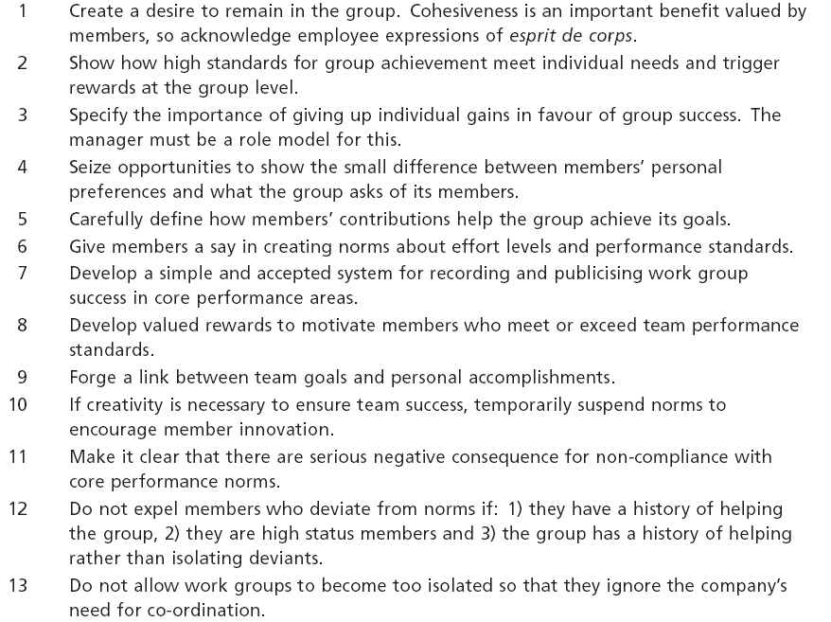

If a group’s critical thinking process is suspended because of high cohesiveness and conformity, groupthink is present. The following is a list of indicators that groupthink might be present:
- The illusion of invulnerability
- Collective rationalization (group members are collectively oblivious to indicators that could spell trouble)
- Mindguards (group has self-appointed guards who sift through and eliminate unwanted negative external information)
- Belief in inherent morality of the group
- Negative stereotyping of the opposition
- Direct pressure applied to dissenters
- Self-censorship
- Illusion of unanimity (each member mistakes the silence of others as agreement)

How to safeguard against groupthink:
- The leader assigns the role of the critical evaluator on a rotating basis to members of the group.
- Influential members should not pre-specify solutions or methods for reaching solutions.
- Leaders might have subgroups (or individuals) arrive at their own conclusion first before polling the entire group.
- At intervals, outside experts might provide guidance to the group.
- When group decision-making deals with competitive organizations, sessions should be devoted to exploration of warning signs and possible forms of retaliation.
- After the group has made its decision, a “second chance” meeting to provide a forum for expressing doubts should be held.

Aspects of group structure
The group structure is defined as the arrangement of roles or positions within the group. Positional status refers to the rank of a position in a work group and is expressed in the amount of responsibility for managing the group and the group’s hierarchy of authority. Personal status is the rank, standing, or prestige of the individual in the work group.

Group size influences several aspects of a group:
- As a group size increases the range of abilities, talents and aptitudes of members for task accomplishment increases
- Larger groups provide for more opportunity to meet interesting colleagues as well as the opportunity for more anonymity.
- As work group size increases the opportunity for direct participation decreases and some members might become reluctant to voice their concerns in a larger group.
- As work group size increases the opportunity for internal conflict increases.

The following diagram shows the relationship between group size, performance, and process losses:
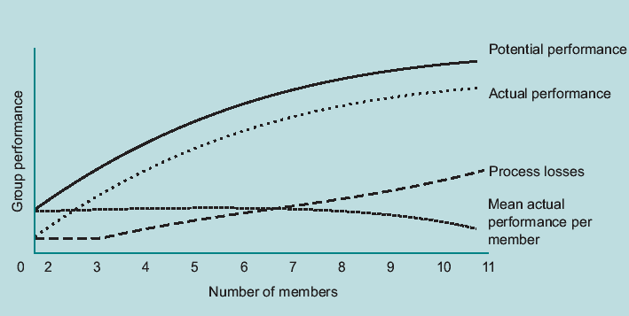

The following summarizes observations about group sizes:
- 2-3 member groups can make members very anxious about their high performance visibility
- 2-5 member groups are better able to reach consensus than large groups
- 4-5 member groups foster greater member satisfaction than middle or large size groups
- 5-11 member groups tend to make more accurate decisions than groups outside that size range
- 11 or more member groups generate more ideas but as size increases beyond 20 members the mean performance per member starts to decline.

Group Dynamics
The following figure shows the stages of work group development:

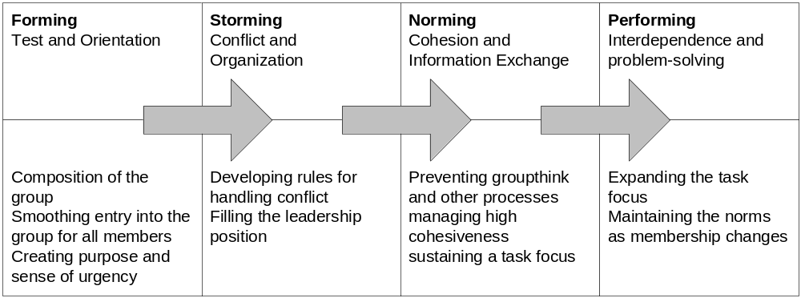

Forming is the group phase-in during which the members move from a personal to a groups focus. Members wrestle with identifying important behaviors, assessing skills, abilities, etc. of members, discussing the goals and motives of members, and assessing the degree of commitment in the group.
Storming is the phase during which members may become more assertive in their opinions about the group’s purposes, methods and norms because they are accumulating more knowledge about the work group. Member dissatisfaction with the current leader may surface and the leader may be replaced. If teams conclude that they are better off reaching their goals on their own, the group will never get past this stage.
Norming: As interpersonal conflict subsides and the work group’s normative structure emerges.
During the Performing stage, the actual performance is close to potential performance because the group is minimizing its process losses.

Brainstorming, Nominal Group Technique, Delphi Technique

Brainstorming is a technique for generating ideas, not for evaluating them. It does not require accountability for the idea, so creativity is more abundant and less inhibited. Brainstorming procedure and rules
- Assemble the work group and appoint a session leader
- Define the purpose and/or problem (ideas, strategies, solutions, alternatives, etc.).
- Set a time limit for the session.
- Select a recording method
- Review the rules of brainstorming:
- Break down complex problems into problems specific enough to be brainstormed.
- Any suggestion or idea can be proposed by any member at any time.
- Ideas must be generated as quickly as possible.
- Use ideas already suggested to spawn new ones.
- Criticisms or evaluations are not allowed during the ‘brainstorming period’.
- Lengthy explanations or discussions are to be postponed.
- The more suggestions the better.
- The session runs for the allotted time or until no more ideas are
- forthcoming.
- Idea evaluation is separate from and follows idea generation.
- Do not use brainstorming as a substitute for individual thinking.

The nominal group technique (NGT) separates idea generation from evaluation; it lessens the influence of dominant individuals in the group, ensures the systematic movement towards aggregation of votes to a preferred outcome, and is usually experienced by group members as satisfying. NGT procedure:
- The question under study is posted in front of the group whose members silently generate ideas in writing without looking at the work of others or discussing the question (5 to 10 minutes).
- The session facilitator goes around the table and asks each participant to read one idea from his or her notes. This idea is recorded in some way. In a round-robin fashion, all participants present their ideas for recording until all are shown.
- Each idea recorded is discussed in the order it appeared. The session facilitator reads each item and asks the participants if there are any questions or points needing clarification.
- Each member records the ideas on 3’×5’ cards and rank orders them secretly from 1 to n. The mean average rankings are used as a basis for the group’s decision. The NGT process can end here or the decision may be refined through discussion and rewording. The voting patterns can be analyzed and reasons can be examined to see if more accurate decisions can be made.
- A final vote is taken in the same way as in step 4. This vote closes the decision loop so members experience closure to the NGT process.

The Delphi Technique can be used for decision making when the group can not meet. Members may not know other members of the group. This technique also eliminates the effect of dominant personalities and member status in the group. Delphi procedure:
- Each group member independently and anonymously records comments, suggestions and solutions to the problem facing the group.
- All the data generated in step 1 are sent to a centrally located individual who is responsible for data compilation and reproduction.
- Each member receives a copy of all written comments from other members.
- Members generate feedback on other members’ comments, and all second round feedback is written down and sent to the centrally located individual.
- Steps 3 and 4 are repeated as many times as necessary to reach consensus.

Maintenance and Task Activities
Groups spend time on task and maintenance related activities. The following guidelines help to minimize the process loss in the group:
- Define work groups tasks and problems carefully
- Do not jump to idea evaluation before idea generation has created numerous alternatives
- Avoid groupthink
- Manage the norms of the group by making values rewards contingent on high-quality group performance
- Make group level rewards contingent on the group’s contribution to work unit success

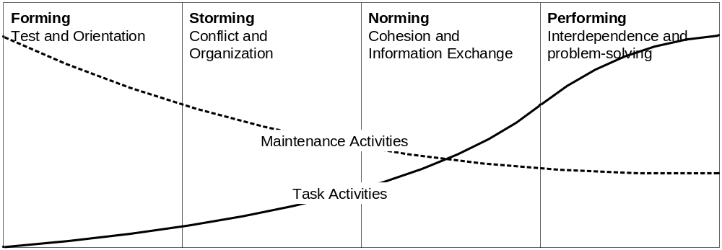

Intergroup Behavior Management and Performance
Groups interact with each other due to the following reasons:
- Interdependence
- Information flow
- Integration

Interdependence refers to the frequency and quality of the interaction between the groups. If the groups have a high level of uncertainty (tasks unclear and/or highly complex), the information requirements rise rapidly. If the number of interacting groups rises together with task uncertainty, the information requirements escalate.
If integration requirements between the different groups are low, they can become highly differentiated and develop their own methods and forms of communication. Integration requirements generally rise with an increase in task uncertainty.

When and if a company switches from a hierarchical to a delayered structure with self-directing teams, the above factors can cause major obstacles in successfully making the change in the organizational structure. The following pathways can help in developing effective intergroup relations:
- Create rules and procedures to ensure communication and cooperation between groups for tasks requiring cooperation.
- In order to foster better understanding between the groups, members might be exchanged temporarily.
- Formally creating a position (linking role) designed as overseeing and linking the groups.
- Using task-forces to temporarily create a group filling the linking role.
- Due to a need for fast decision-making, organizational security, or intergroup conflict the groups might benefit from decoupling them (potentially just temporarily).

Social Loafing
Theoretical reasons for social loafing:
- Equity of effort (“no one is working hard, why should I”)
- Loss of personal responsibility (“no one will miss me in the large group”)
- Reduced effort caused by reward sharing (“everyone is paid the same, why should I put in the extra effort”)
- Co-ordination complexity in larger groups (“we are all stepping on each others feet”)

How to manage social loafing:
- Focus on the interesting and important aspects of the task to increase the level of job involvement of group members.
- Assure group members that their individual contributions are identifiable and significant.
- Tell group members that they should not tolerate inadequate effort or performance from group members.
- Tell them that they should expect to have their performance evaluated.
- Ensure that some portion of rewards received by group members is dependent on their performance.

Deciding upon the extend of participation in decision making
The Vroom-Yetton-Jago normative decision model lists the following forms of decision making:
AI: A manager makes a decision alone, using the information currently available. This is the most authoritarian, boss-centered style of decision-making.
AII: A manager seeks information from subordinates or group members and then makes a decision. Employees may or may not be aware of the problem before the manager takes a decision.
CI: A manager explains the problem to his subordinates in a one-to-one format. The manager takes a decision which may or may not reflect the ideas of his subordinates.
CII: A manager explains the problem at hand to his subordinates in a group format. The manager takes a decision which may or may not reflect the ideas of his subordinates.
GII: A manager explains the problem to his subordinates in a group format. With the manager, the group makes a final decision.

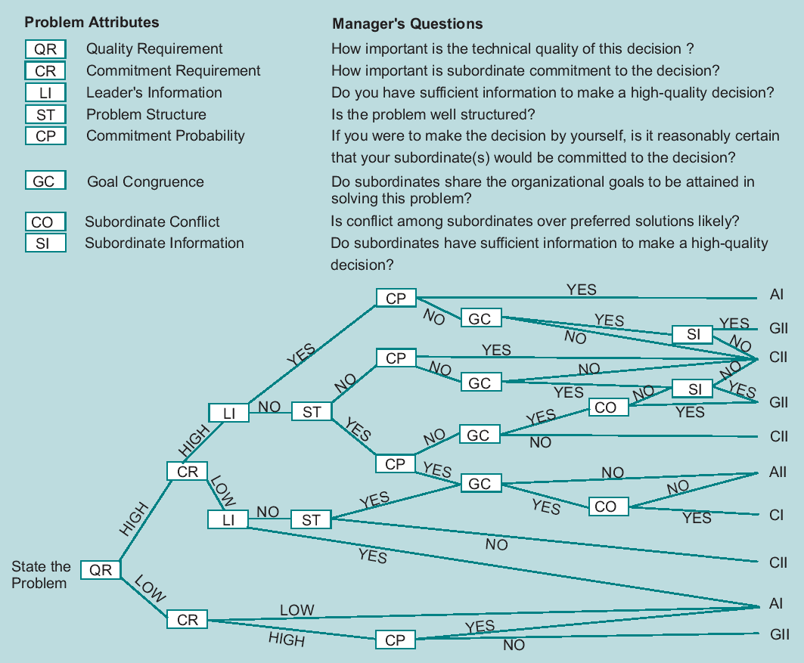

Group Conflict Management
Group Conflict can be seen as either dysfunctional and unhealthy to the organization or as a by-product of organizational life that is unavoidable but manageable. The following methods can be used to deal with conflict:
Avoidance: this is usually a short-run, damage control strategy. It is used when
- the issue is trivial,
- there is no chance of satisfying the concern,
- the cost of disruption outweigh the benefits of resolution,
- people need to calm down to gain perspective, and
- gathering information is more important than action
Accommodating: should be selected when
- a manager decides he is wrong and shows reasonableness,
- an issue is more important to others than it is to the decision maker,
- to cut losses when in a loosing argument,
- the goal of harmony is more important than the potential benefit of the resolution, or
- employees can benefit from learning from their mistakes.
Forcing: should be selected when
- emergency conditions require decisive action,
- the issues is extremely important and unpopular actions have to be implemented,
- the company is at stake and the decision maker knows he is right, or
- an organized opposition would take advantage of non-competitive behavior.
Compromising: should be used when
- the decision maker believes that her goals are important but insisting on them in not worth the potential disruption caused by other, more forceful measures,
- the opponent has equal power and is committed to mutually exclusive goals,
- a temporary solution is needed for a complex issue,
- time pressure dictates a quick resolution, or
- serve as a backup when collaboration has not worked.
Collaboration: both parties are involved in solving the problem permanently through mutual commitment to the solution. Usually these steps are followed:
- Define the problem and share the facts (rather than make emotional appeals and distort facts).
- State the problem in specific terms before searching for solutions.
- Once facts are collected, focus on them instead of focusing on the disagreement.
- Conduct non-judgmental discussion of the facts and the problem.
- Collaborate on alternatives which lead to the best mutual solution rather than those alternatives which lead to solutions favoring one party’s interests.
- Develop criteria for measuring the quality and acceptability of the proposed solutions, agree on them, and present the solutions for criteria review before one is selected.
- Define all agreements as tentative until all facets of the conflict have been addressed. Thus, there is no implementation of any agreement until both parties are convinced they can support the solution.

Module 7: The Influence Processes in Organizations: Power, Politics, Leadership and Entrepreneurship

Types of power and how to obtain it
Power is the ability to influence someone else. It is the capacity to modify employee behavior in a desired manner while being able to avoid having one’s own behavior modified in undesirable ways. Power has the following characteristics:
- It can only be wielded in a relationship which other people depend upon in some way. It has no meaning outside of human relationships.
- Individuals can learn to wield power effectively
- power can flow in any direction in an organization

Authority is the right to order or ask others to do what you want them to do.

Influence is the process of affecting the thoughts, feelings, and behavior of others.

Interpersonal power can be classified in the following ways:
- Reward power is the capacity to exert influence by providing positive outcomes and preventing negative outcomes. It is often used to back up legitimate power.
- Coercive power is the capacity to exert influence by the use of punishment and threat. Again, it often supports legitimate power.
- Legitimate power is the capacity to direct the behavior of others due to one’s position in the organizational hierarchy.
- Referent power is based on the extend to which the power-holder is well-liked and admired by others. Referent power is important in interpersonal relations because it is based on interpersonal attraction and is much more personal than either reward or coercive power.
- Expert power represents power gained through the possession of expert knowledge that is valued in the organization.

In order to ensure that power is used ethically, one should ask oneself the following three questions:
- Does the behavior produce a good outcome for all internal and external stakeholders?
- Does the behavior respect the rights of all stakeholders?
- Does the behavior treat all stakeholders equitably and fairly?

How do employees obtain power?
- Building an image of success.
- Creating obligation in others (quid pro quo).
- Identifying with powerful people.
- Giving excellent performance.
- Limiting access to information,
- Controlling supplies, resources.
- Developing a network.
- Reorganizing the job (refers to taking on new responsibilities, adding objectives and tasks to one’s work)
- Taking risks and being creative
- Being a knowledge worker (gaining more knowledge to solve a given set of organizational problems)
- Manipulating rules (that is sticking to processes and procedures when they are helpful and trying to change rules when they further the acquisition of power)
- Controlling personnel decisions
- Controlling financial resources
- Managing your boss

The following factors influence the ‘power’ of a subunit or organizational group:
- Scarcity
- Uncertainty
- Centrality
- Absence of Substitutes

The following table shows a way to classify and define political activity in companies.

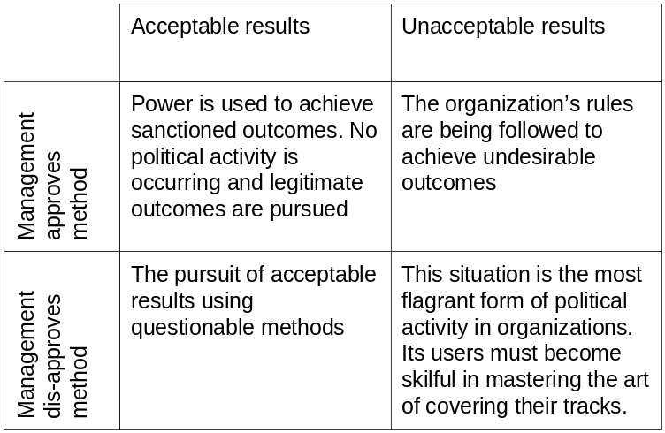

Politics
Whistle-blowing behavior occurs when an individual believes the organization is violating his instrumental or terminal values, or the law. Thus, whistle-blowing means that the individual informs a reporter, police officer, government official or other influential individual about an assumed injustice, irresponsible organizational action or violation of the law. The behavior bypasses the organization’s hierarchy of authority. High-level managers are usually infuriated if
they learn about the whistle-blowing.
Line versus staff conflict refers to the inherent disputes which must arise when staff units are created in the organization. Staff experts have specialized knowledge which can greatly improve the quality of line management decisions. Line managers fear the encroachment of staff experts in their line authority. Both line and staff personnel practice
- withholding information,
- gaining access to powerful executives,
- building better images and
- increasing centrality.
Sponsorship and coalition-building are forms of counterinsurgency used by individuals to gain the favor of powerful individuals. The employee attaches himself to someone (or to a group) which is gaining power in the organization. The only rules governing this political behavior are:
- stay personally loyal to the sponsor or department,
- follow the orders of the sponsor,
- stay in the background to let the sponsor have all the credit and
- show gratitude.
Insurgency or resisting authority is often characterized by ‘following the letter of the law’, or interpreting and enforcing policies in a manner unintended by management.

Managing your manager
Employees often make the following two mistakes about their relationship with their superior:
The manager already knows everything he needs to know and also knows all possible alternatives for decision making. This attitude limits the options to aid one’s manager in participatory decision making. Base your work relationship with your manager on:
- both of your needs for achievement and decision-making styles;
- well-understood expectations;
- keeping your boss informed,
- dependability and honesty,
- documented performance and
- selective use of your boss’s time and resources.

Management and Leadership
The following items highlight the ten most common roles a manager plays. They fall in three categories:
Interpersonal relationship maintenance
Figurehead/chief: Testifies in court and at regulatory hearings. Cuts ribbons and opens new offices/facilities.
Leader/encourager: Gives pep talks and holds open meetings with workers and staff. Passes out awards and honors. Hires and fires.
Liaison/linking pin: Presides over industry trade group or professional society/certification group
Informational (generation and transmission of data and knowledge)
Monitor/surveyor: Reads industry reports and meets with vendors
Distributor: Holds meetings, writes memos and sends e-mail
Advocate/spinmeister: Makes speeches, meets with the press, grants interviews
Decisional (deciding and controlling)
Creator/entrepreneur: Scans and detects new ideas/product innovations/ industry trends
Crisis controller: Acts quickly in a dilemma and makes decisions to limit perceived damage
Resources distributor: Sets and manages the budget in relation to the firm’s strategic plan
Mediator/negotiator: Solves work stoppages/grievances and disputes with vendors and distributors

Research in to leadership can be broadly categorized in to the
- trait approach (the leader himself has some influence on the outcome of work and the success of the organization), the
- behavioral approach (stresses the importance of the constancy and predictability of leader’s behavior across leadership situations), and the
- situational approach (the leader’s traits and behaviors are considered in terms of the situation that she confronts).

In studying the effectiveness of established leaders, the following broad list of traits stand out:
Logical thinking traits refers to:
- putting ideas into simpler form,
- persuading others and
- explaining things in unique ways.
Persistence traits refers to
- treating setbacks as small mistakes,
- working long hours and
- trying to succeed against formidable odds.
Empowerment traits highlight
- getting people excited about goals,
- being energetic and enthusiastic and
- making subordinates believe they can achieve excellence.
Self-control traits involve
- working under heavy pressure,
- remaining even-tempered and
- resisting intimidation by powerful people.

The trait approach fails to take into account the situation in which leadership occurs. It does not answer the question: “Do great leaders make great situations or do great situations make great leaders?”

The behavioral approach stresses that they key to understanding great leadership is in understanding the behavior that influences employee’s performance and satisfaction. This approach stresses two main behaviors:
Initiating structure refers to leader behaviors which focus on group goal attainment by stressing:
- work procedures,
- planning, assigning tasks,
- clarifying work roles,
- supervising subordinates and
- asking for results.
Consideration refers to those leader behaviors which exhibit
- approachability,
- supportiveness,
- maintenance of high morale in the work group,
- concern for group welfare and
- maintenance of a collaborative work atmosphere.

Situational leadership theories
Fiedler’s contingency theory proposes that leader behavior interacts with the favorableness of the situation to determine the level of group effectiveness. Some situations are more or less favorable and they require different leader behaviors. Leaders are measured on their assessment of the relationship to their least preferred co-worker on several bipolar scales (e.g. pleasant – unpleasant, warm – cold, etc.). A leader with a high LPC score is relations oriented, a leader with a low LPC score is task oriented. The situational favorableness has three dimensions:
- Relationship between the leader and the members of the group refers to the quality of work group atmosphere which results in loyalty, supportive relations and trust between the leader and his subordinates.
- Task structure refers to the clarity of the group’s work and the extent to which members understand the goals of the group’s work.
- Position power is the leader’s legitimate authority to tell others what to do.

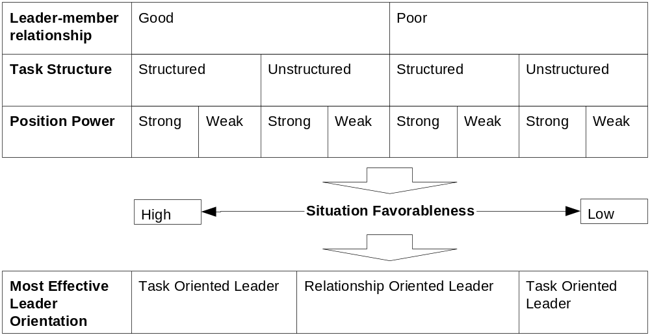

The relations-oriented leader is most effective when the situation is moderately favorable or unfavorable. When the leadership situation is highly favorable, it is not stress inducing; therefore it is possible for the task oriented leader to behave in a relations oriented manner. However, when the work group faces a crisis in performance and the situation is therefore highly unfavorable, the work group needs strong, focused leadership (at which the task oriented leader excels). In the middle positions which vary from slightly favorable to slightly unfavorable the leader is faced with shoring up leader–member relations which is the strength of the relations oriented leader.

How can leaders change the situation that they face?
- Tinkering with relationships at work
- Spend more or less time with subordinates including lunch and after-hours socializing
- Request certain people for group membership or assignments
- Volunteer to supervise or work with troublesome group members
- Transfer certain group members
- Get additional rewards to improve morale
- Listen to employees’ concerns and offer personal advice
- Modifying task structure
- Give the group creative challenges with no constraints on methods
- Provide more standardized assignments
- Divide the work into smaller, more specialized units
- Modifying position power
- Rely on discipline to constrain troublesome team members
- Require that all information and group decisions are reviewed by upper management
- Delegate more authority to group members (empowerment)

House’s path-goal theory is concerned with situations that cause various leader behaviors to be most effective. The main job of the leader in this theory is the clarification of pathways between subordinates’ performance and the rewards they value. This theory is a transactional theory of leadership, that is, it specifies how a leader exchanges rewards for performance and effort from subordinates. The behaviors which the leader must develop are described below:
- Directive behaviors. These are behaviors such as work planning, setting performance standards, clarifying work expectations and giving instructions.
- Supportive behaviors. Leader behaviors which are friendly, supportive, caring and considerate.
- Participative behaviors. Using subordinate’s ideas in problem-solving.
- Achievement-oriented behaviors. Setting goals for subordinates and expecting them to achieve them.
Under this theory a leader analyzes a subordinate’s characteristics like task abilities and need for achievement as well as environmental factors such as task clarity, routineness, and challenge. The leader then has to match his behavior to the interplay of subordinate characteristics and environmental factors.

Leaders use rewarding and punishing behavior in four different ways:
- Performance contingent reward behavior: Using praise, recognition and affirmation contingent on employee job performance. This behavior has proven to result in higher employee performance and satisfaction.
- Contingent punishment behavior: Using reprimands and punishment contingent on insufficient employee job performance. It is not clear that this behavior achieves changes to the lack of employee’s performance.
- Non-contingent reward behavior: Using rewards independent of performance.
- Non-contingent punishment behavior: Using punishment or reprimands independent of the performance of the employee. This type of behavior has a strong negative effect on employee performance and satisfaction.

Entrepreneurship
What sets an entrepreneur apart from a manager in a large corporation and a small business owner: Sexton and Bowman-Upton argue that dissatisfaction with the status quo and the ability to recognize an opportunity, exploit it and make a business grow set the entrepreneur apart. Entrepreneurship can be defined as a process of opportunity recognition followed by a plan to exploit the opportunity.

Dimension of Behavior | Entrepreneurs tend to … | Administrators tend to …
Creating value-added strategies | - Spot opportunities  - Radically change the firm  - Exhibit self-confidence  - Believe in the firm’s capabilities | - Control the flow of resources  - Make incremental changes in methods  - Efficiently use the firm’s current resources
Taking decisions | - External product and process opportunities are closely linked to the personal value that change is valuable and meaningful  - Flat structures best keep the firm flexible and fluid (cross-training is a must) | - Separate personal beliefs about external opportunities and change (change is not always good)  - Checks and balances are more important than rapid decision-making
Tackling problems in the firm | - Minimize risk by leasing or renting facilities and equipment  - Always be prepared to add capacity | - Own equipment and facilities and add capacity only when capital costs are manageable.
Using incentives | - Keep salaries low and use ISPs to retain talented employees  - Use bonus and individual and team levels | - Develop and maintain merit-based reward systems  - Periodic salary surveys to ensure competitive pay

A typical entrepreneur:
- Is tenacious and makes sacrifices
- Pursues achievement
- Is directive
- Assumes personal responsibility
- Solves problems
- Appreciates novelty
- Has an internal locust of control
- Tolerates ambiguity
- Takes calculated risks
- Handles failure

How do organizations encourage entrepreneurial employees and innovation?
- Each innovation in an organization begins with an idea champion that generates an idea and retains responsibility for developing the idea in the organization.
- For each idea champion there needs to be a sponsor who nurtures the new concept and applies organizational resources to the increasingly disruptive and expensive development of the idea.
- For the new concept to succeed, the organization must have employees who occupy the role of orchestrator or godfather who handles all of the political obstacles surrounding the commercialization of the product, service, etc.
- Large organizations might also need to create horizontal co-ordination mechanisms which protect innovation teams from outside influences (greenhouses)

Module 8: Organizational Design and New Forms of Service-Driven Organizations

Organizational Design
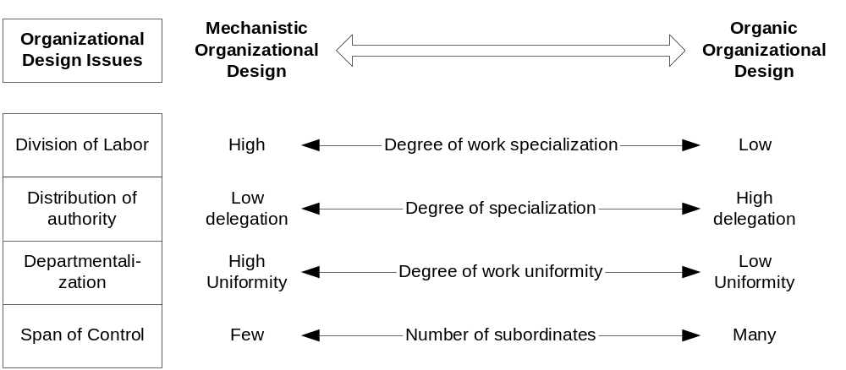

Division of Labor is the degree of job specialization in a firm. It is the specific tasks and work methods of an employee’s job. Division of labor results in specialization and it is the primary source of increasing marginal productivity in work units.

Delegation of authority is a manager’s decision about how much authority to give to a subordinate. When delegating authority managers loose some degree of control but gain the advantage of leveraging the subordinates skills and expertise. This allows the manager to take on more complicated tasks. When receiving authority a subordinate is able to acquire management skills. Gaining authority can be a powerful motivator (intrinsic reward) which raises subordinates’ effort levels. Delegation of authority should always follow the following principles:
- For each responsibility delegated to a team or a subordinate, an equal amount of authority must be given.
- All decisions should be delegated to the lowest organizational level possible, i.e., to the level at which employees or self-directed teams who know what to do can act responsibly on behalf of the firm.
- Managers just get involved when an exception to the work routine of the team or subordinate occurs (management by exception).
- Managers should not only tell the team what to do but also check in to make sure that the subordinate knows how to complete the task.
- The subordinate’s responsibility to his superior is absolute and superiors cannot escape responsibility for the performance of their subordinates.

Departmentalization refers to how work activities are grouped together. Departmentalization is the logical grouping of work activities to create divisions, branches, units, etc. in a company. Companies can be grouped in many different ways:
- Functional design established workgroups based on the function that they perform in the company
- Territorial design establishes work groups based on a geographic area
- Product divisional design establishes the work groups based on products of the company
- Matrix design overlays a project or product design on a functional design.

The principal advantages of the functional design are noted below.
- The structure is a logical reflection of the firm’s functions.
- It is based on specialization (i.e., the purchasing department has expertise in buying all the components and materials which go into production) which is efficient.
- It is efficient because individuals in functional departments learn to speak a common language (accounting, purchasing, quality control, and so on).
- It minimizes the extent of duplication of effort.
- Training of employees is narrowed and simplified.
- It facilitates tight control and the legitimate authority of the chain of command is reinforced.
Disadvantages of functional design:
- Overspecialization can take place and this can narrow the business viewpoints in functional departments.
- The development of managers is limited to their functional areas.
- Coordination between departments can weaken.
- Employees identify more strongly with their departments than with the culture of the firm.
- The chief executive may be overburdened.
- Managers may fail to develop a strong focus on customers, products or markets.

The principal advantages of the territorial design are the following:
- It tailors work units to the particular features of customers in a given region, i.e., British, Japanese, American, and French.
- It provides an excellent training ground for managers as they are assigned to different regions.
- It provides an excellent basis for the career development of managers (movement from field operations to company headquarters).
- It creates work units that are highly responsive to specialized customer needs.
There are a few disadvantages which occur in the territorial form of departmentalization:
- There is a danger of duplication of effort across departments serving various territories or regions.
- The company must be able to hire general managers who are capable of handling several functions such as production, sales and human resources.

The principal advantages of the product divisional design are as follows:
- It provides adaptability and flexibility in meeting the needs of customers and the company’s ability to manage a set of related products.
- External changes can be detected more readily and understood in product-relevant terms.
- Employees gain deep understanding of product and market characteristics (product divisions are good training grounds for developing managers with generalizable skills).
- The structure encourages the development of separate business units (profit-centers) which top management can pit against each other through friendly competition to maximize profits.
- Performance measures are easy to create and judging the performance of various product divisions is less complicated.
- The design shifts some of the burden for general management from corporate executives to division executives (This reduces the extent of diversity in the chief executive’s job making easier the management of a large company with diverse products, customers and territories).
The principal disadvantages of the product divisional structure are as follows:
- Product divisions can duplicate effort and resources as they attempt to solve similar problems without consulting other divisions (The corollary to this is that corporate executives have less day-to-day control over product division operations).
- Finding and training people to head each division is a difficult job.
- When product divisions attempt ‘joint ventures’ conflicts can arise due to sharing resources and agreeing on ‘transfer prices’.

The principal advantages of the matrix design are noted below.
- The matrix design combines the strengths of the product divisional and functional designs.
- The design blends an emphasis on market changes with management and technical expertise in given product or project areas.
- It develops managers with technical product and project knowledge who can communicate effectively with marketing, production, and personnel from other functional departments.
- A self-contained department can devote its undivided attention to the needs of its product, project or customer groups.
- The firm can focus on specific products and their development without creating permanent units which may outlive their usefulness.
The disadvantages of the matrix design include the following:
- It is a confusing design because employees may not know who their ‘real boss’ is. The project manager is worried constantly about the project, while the functional manager frets over departmental details. This confusion can lead to political game-playing and loss of work focus in the project and functional areas.
- The design requires excellent planning and resource allocation to ensure that functional work proceeds and projects do not ‘starve’.
- Project managers must have excellent technical, political communication, and managerial skills. When an organization decides to ‘go matrix’, it must often do extensive training or hire new employees with project management experience.
- The design may lead to excessive overhead costs because projects may over-hire technical and support staff.

The span of control is defined by the number of subordinates that a manager is supervising and the intensity of the interpersonal relationships. The following factors influence the span of control:
- Required contact between manager and subordinate
- Degree of specialization of the subordinates managed
- Ability of the manager to communicate

Centralization is the retention of authority to make decisions by top management. Decentralization is the process of pushing authority down the organizational hierarchy so that decisions are made as close to the origin of organizational problems as possible.
Highly centralized firms usually trigger:
- Formalization, which is defined as written documentation of rules, regulations, and procedures which guide employee behavior and organizational decision-making.
- Standardization, which is the degree to which behavior variation is allowed in a job or a series of jobs.

Strength and weaknesses of decentralized designs
Strength | Weaknesses
Meshes well with rapid change and fast company growth | Innovation is often restricted to projects or specialized programs
High awareness for projects, programs, or products | Difficult to allocate pooled resources such as computer analysis
High task focus that yields control over time, financial, and human resources | Co-ordination problems in joint functions, such as purchasing
Customer can determine task responsibilities and project-personnel are highly responsive to their needs | Deterioration of broad managerial skills and potential for loss of technically skilled employees
Concurrent multiple tasks can be coordinated across functional departments | Jurisdictional and priority disputes
 | Possible neglect of high level coordination to ensure organizational effectiveness

The two common forms of inter-organizational designs are conglomerates and strategic alliances. A conglomerate is a holding company that acquires many other companies which have entirely different business strategies and operate in diverse industries. It is the expression of the strategic principle of unrelated diversification. Unrelated diversification is the acquisition of companies because they are:
- undervalued,
- financially distressed; or
- likely to grow but cannot because they have limited capital.

Keiretsu is a corporate system that links suppliers and manufacturers that are clustered together to take advantage of geographic, logistical, and financial proximity.
A strategic alliance is a cooperative agreement between two firms that fall short of a merger or full partnership. They are best thought of as a transitional arrangement that can be used to overcome a competitive disadvantage in international markets.
Strategic alliances are used to gain economies of scale in production or marketing, or fill perceived gaps in technical or manufacturing skills, to gain access to markets by lowering entry barriers. The drawbacks of alliances are that they require exhaustive coordination through meetings and task forces, decisions have to be made on what is shared and what remains proprietary, overcoming language and cultural barriers, the need to rise above suspicion and mistrust, and the potential to depend too much on expertise in another company.

Coordination and Control
What determines how much coordination is necessary between work groups? The amount of coordination necessary depends on the amount of information that needs to be processed during task execution. When is a high amount of coordination necessary?
- When the tasks are unclear
- When the environment is turbulent

Coordination is required to reduce the amount of uncertainty for employees and their subunits about what they are supposed to do. Vertical coordination strengthens the link between organization levels.
- Teams and task forces (e.g. in a collateral organization, that is an organization that is set up in parallel to the normal functional organization to supplement it)
- Direct supervision
- Standardization of work processes
- Standardization of outputs
- Performance appraisals
- Management Information System
Horizontal coordination mechanisms ensure the orderly processing of the company’s workflow:
- Direct contact
- Liaison roles
- Cross-functional teams
- Permanent teams to manager recurring workflow problems

Control is the set of mechanisms used to keep action and outcomes within predetermined limits. It is the setting of work standards, measuring results against plan, and initiating corrective action. Control can be used in the form of either process control or results control. Process control deals with the standardization of task performance in order to achieve economic efficiency by reducing the marginal costs of production. External process controls that are often perceived as resulting in mindless jobs have been largely replaced by internal process controls applied by self-directed teams. A popular results-oriented control system is management by objectives (MBO). MBO systems try to ensure that managers set specific measurable goals, monitor progress toward these goals, and receive rewards based on their accomplishments. Firms relying on output controls can remain more open to environmentally induced uncertainty.

Management by Objectives (MBO) steps:
- Members of the work unit establish goals and action plans for achieving those goals.
- Discussion of work unit goals ensures that everybody understands them.
- Employees in the work unit establish their own action plans for achieving their goals. The managers participate in one-to-one meetings with employees. Here the goals are made specific and quantifiable if possible.
- The superior and subordinate jointly establish outcome criteria for assessing success.
- The superior conducts periodic formal and informal feedback with employees concerning individual and work unit goals.
- The system is documented with all goals set down on paper.
- Goals are ‘cascaded’ down the hierarchy. They become more specific and quantified at lower levels.

The following problems have occurred when implementing MBO:
- Employees can develop tunnel vision about results and they may not give adequate attention to how task activities should be done. MBO can be more effective if it is linked to product and service quality standards.
- MBO degenerates into a ‘paper chase’, emphasizing red tape and completing forms in triplicate. This may occur when MBO is linked to external process control mechanisms.
- Superiors fall into an ‘either punish or reward’ mentality regarding results achieved by subordinates.
- The collaborative aspects of the system are lost if employees have too many goals or they are worried about accomplishing their specific goals.

Responsiveness
In order for companies to maintain responsiveness in today’s markets they have used a number of strategies to regain or maintain their competitive advantage. The following are some strategies used successfully:
- Simplify and delayer
- Reassign supporting staff employees
- Widen spans of control
- Empower the workforce
- Create team based work systems

The boundaryless organization is one in which traditional vertical and horizontal boundaries are made more permeable and flexible by using self-directed teams, technologically sophisticated communications, responsiveness to customers, outsourcing, and strategic alliances.
The authority boundary is the natural distinction between leaders and followers in firms. To overcome the authority boundary managers must learn to lead while remaining open to criticism and advice from lower ranking employees that are experts on the various problems that arise. In tight economic environments down-sizing and other decisions taken by management often lead to a reappearance of the authority boundary.
The task boundary emerges when someone decides who must do what when departments work together. The biggest threat to overcoming the task boundary is management’s view of cost versus investments. When management sees accounting view of costs (like training, R&D, etc) associated with employees they will drive towards minimizing cost. When managers instead adopt the ‘value-added’ approach all costs are seen in the context of adding to future earnings; they become investments.
The political boundary is made up from the different political agendas which can divide company units and create conflict. The boundaryless firm manages such political disagreements by creating a culture which emphasizes the best interests of the work teams, the network and the firm through the complementary processes of accommodation and conflict management.
The identity boundary consists of employees’ shared experiences and beliefs which they insist set them apart from the rest of the company. When this boundary is well developed, members of departments and work groups have an ‘us versus them’ attitude. To overcome it, firms try to excel at socializing new members to get them to identify with the company and its goals.

The following flowchart summarizes the steps that a company must go through create a horizontal organizational design:
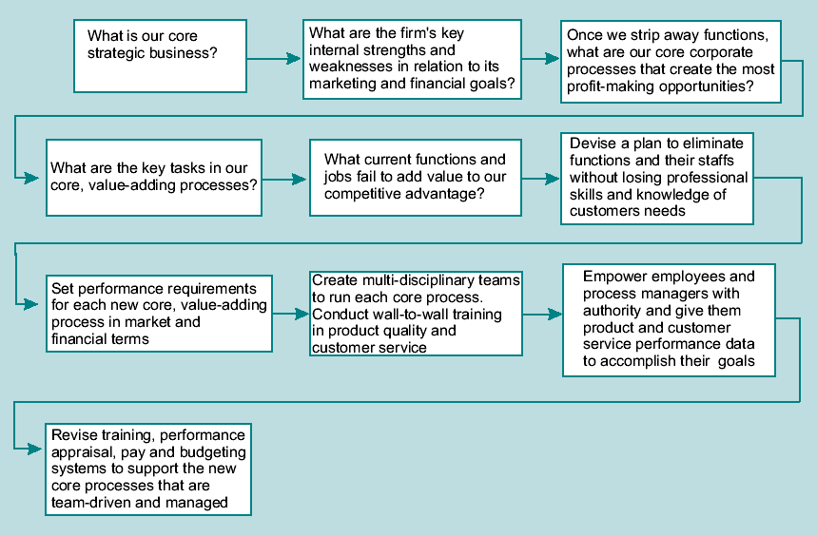

Customer Service
The following reasons explain why service quality improvement is a driver of sustainable competitive advantage:
- Differentiating service is often easier and faster than differentiating products in terms of their physical characteristics.
- Customers demand better quality.
- Service improvements strengthen brand loyalty and erect market segment and industry entry barriers.
- Bad service quickly drives off customers and lowers or erases profits.

Producing and developing services differs from manufacturing and selling products in several distinctive and important ways:
- Not until service is demanded is it produced
- Service is often provided by employees not under the direct supervision of a manager
- Services are provided when and where the customer desires.
- Services are labor intensive.
- Service is intangible and its characteristics are more difficult to measure than the features of a product with distinctive performance and physical characteristics.
- Service is often produced in the presence of the customer who participates in the delivery process.

A ‘moment of truth’ occurs in service delivery when the customer encounters any aspect of the firm and forms an opinion about the quality of its services and products. These moments accumulate and the customer forms a durable opinion about a firm’s interest in his satisfaction and repeat business.

For a firm to achieve competitive advantage through service improvement, the three factors described below must guide all changes to the firm’s service mix:
- A well-conceived strategy for service
- Customer-oriented front-line people
- Customer-friendly systems

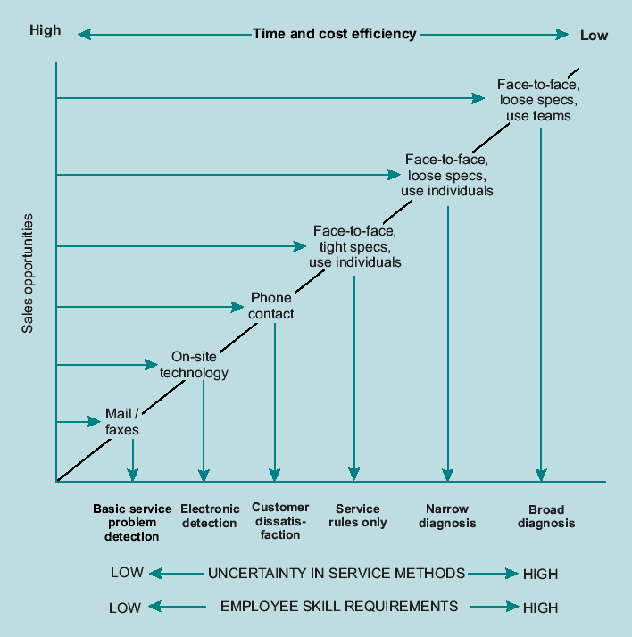

The principles of service quality improvements are the following:
- Classifying the services on the client/customer spectrum (see below)
- Organizing to improve customer service
- Using employee empowerment
- Abandon manufacturing assumptions in service quality delivery

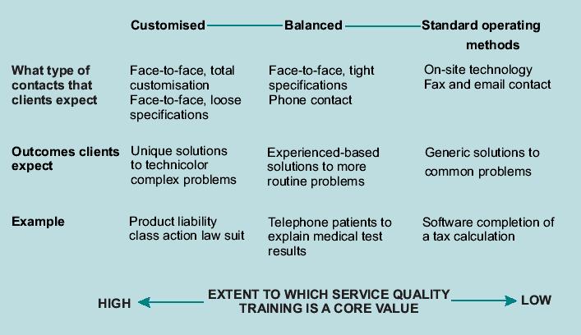

Steps necessary to create a service-driven organization:
- Conduct a service audit
- Develop a company wide service strategy
- Conduct ‘wall-to-wall’ employee training
- Implement the service improvement program
- Make the service improvements permanent

Module 9: Managing Transitions: Organizational Culture and Change

Organizational Culture
Organizational Culture is the value and beliefs which are understood by employees. Communicated values and beliefs become shared employees expectations. An organization might have multiple cultures, e.g. reflected in the specific professional orientations and skills of groups of employees. The quality of the fit between the organization’s culture and its strategy direction influences the organization. A strong culture that integrates the various subunits and occupational cultures enables excellent integration and methods for managing conflict.

Disadvantages of a strong company culture:
- A strong culture might limit the flexibility of a company in the face of rapid change required to adjust to changed circumstances.
- Strong cultures may not mix well when one firm acquires another.
- Some strong cultures threaten reaching of organizational goals because the culture legitimizes infighting, secrecy, and empire-building.

In order to familiarize employees with the culture of an organization, they may go through a socialization process as follows:
- Realistic job previews during hiring
- Debasement and indoctrination are used to humiliate and indoctrinate to open new employees up for corporate norms and standards of excellence
- Intensive on the job training on core job areas
- Adjust the reward and promotion system
- Use top managers as personal role models for the company’s culture
- Reinforce the culture with stories about the organization and it’s founder
- Use mentors to develop younger employees

A company’s culture should:
- The company’s culture should strongly reinforce its long-term financial performance. A strong culture forges powerful bonds among workforce motivation, company financial performance (ROI, ROE, ROA), company controls and organizational structure.
- The company’s culture must align with strategic or market goals. If a company pursues the low-cost producer strategy, its culture must support principles of lean staffing, few management layers, decentralized decision-making and so on.
- The adaptation aspect of culture emphasizes flexibility and it encourages the workforce to adapt to the firm’s financial and market strategies.

The HOME approach to culture improvements stresses the following aspects of improving and creating an organization’s culture. It is based on two principles, the management’s trust and respect for the workforce and the improvement of the quality of the employment relationship in the company.

History
Oneness
Membership
Exchange

The central aspect of organizational culture is adaptiveness.

Why do Organizations Change?
The following table highlights the characteristics of a company’s lifecycle.
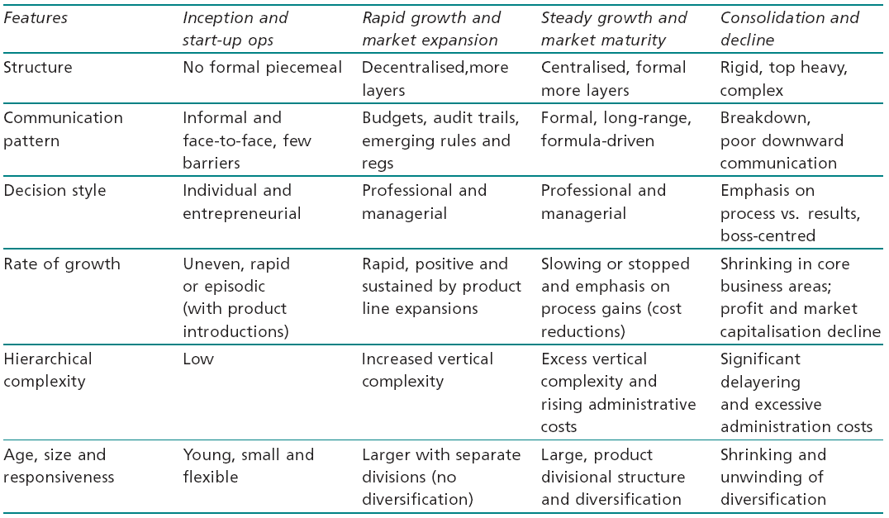

Decline is not an inevitability for a mature company. Managers should look out for changes in the following factors:
- Excess personnel (and excessive job classifications).
- Tolerance of incompetence (failure to dismiss poorly performing employees).
- Cumbersome administrative procedures (excessive red tape and regulations).
- Unusually powerful staff who overwhelm line decision-makers and deride them as conventional and unsophisticated.
- Form over substance, e.g., the planning system and its rules become more important than the results of planning.
- Few clear goals and criteria for measuring organizational success.
- Reluctance to tolerate conflict or preferring harmony over disagreement in spite of its potential damage to decision-making.
- Loss of effective communication and excessive centralization of decision-making.
- Outdated organizational structure.
- Increased scapegoating by leaders (a rise in political behavior at the top of the management hierarchy).
- Resistance to change.
- Low morale.
- Special interest groups become more vocal (resist changes in technology and methods).
- Decreased innovation (fewer new products are developed and introduced in the market).

The task environment in which a company operates is composed of suppliers, customers, competitors, regulatory agencies, and social interest groups. Environmental complexity refers to the number and variety of external constituencies which organizations face. Environmental change refers to the stability of constituencies and whether or not they change rapidly of slowly over time.
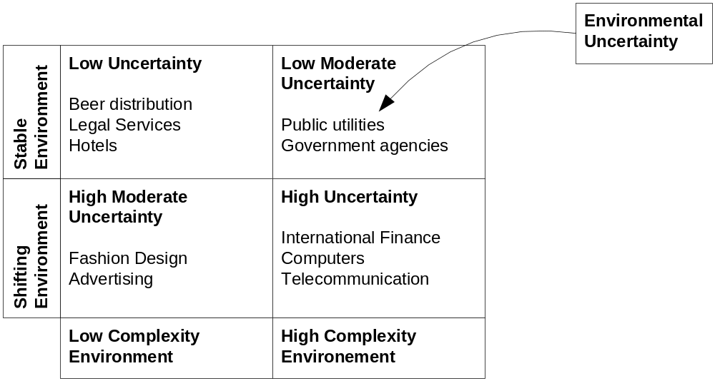

Companies with high environmental uncertainties have to actively plan for change. They must have the ability to monitor and survey their environments constantly and proactively search to anticipate change rather than react to it. In order to do this, organizations can try several things:
- Change of goals and strategies: organizations may introduce new products and services, or segment markets.
- Change of technology: introduction of new (sometimes disruptive) technologies can lead to organizational change.
- Change of structure: Organizations can modify themselves by changing from a functional to a product or territorial design while shifting from centralized to decentralized decision-making.

Indicators of poor organizational health such as
- diminished productivity,
- increased customer complaints,
- increased absenteeism,
- increased grievance rates and
- strikes
may point to problems that the organization has in order to deal with

Organizations often respond to these environmental challenges by changing.
- Job design. The work performed by individuals or teams can be modified to provide more opportunities for satisfying the needs of employees.
- People. The organization improves the quality of service and speeds up decision-making by developing a program of employee empowerment based on the use of self-directed teams.
- Control systems. The organization can alter its performance appraisal and reward systems. These changes encourage new behaviors which employees believe will result in their receiving rewards which they value.

In order to make successful corporate transitions three conditions have to be met:
- Dissatisfaction with the status quo among employees who must change their behavior.
- The need for a model or vision of the future, which will guide the redesign of the organization.
- The need for a well-managed process of change to help employees modify their attitudes and behavior.

Organizational Change Process

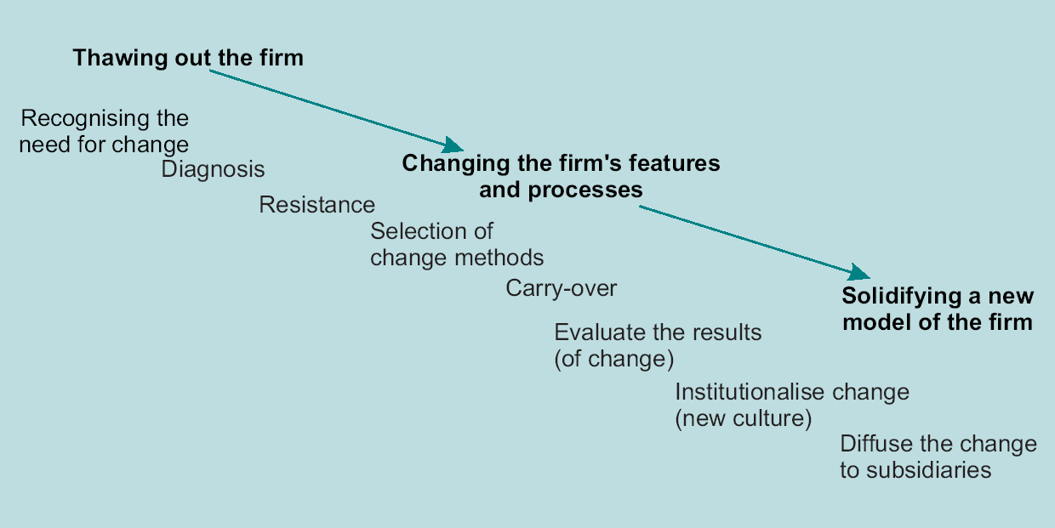

Planned change goes through the following stages:
- Unfreezing occurs when employees feel dissatisfied with the old culture and processes in the organization. Unfreezing represents the ‘constructive destruction’ of ineffective company processes and features. It may also entail management’s realization that the company’s work system, training and development system, performance appraisal system or structure does not fit strategy.
- Diagnosis is the collaborative process between the organization and a change agent to bring organizational problems into focus. A change agent is an expert in the application of behavioral science knowledge to organizational diagnosis and change. Diagnosis is an integral part of the unfreezing process and it is usually triggered by an internal or external event which has created uncertainty for managers.
- Changing occurs when an action plan is implemented to move the organization and its members to adopt new behaviors and accept changes to culture.
- Resistance happens when employees fear that the personal and organizational costs of change will exceed the benefits. They feel that they or the organization or both are threatened by the change. The other side of the resistance ‘coin’ is preference for the status quo. It may be so comfortable that employees fear any alterations, which might cause
- economic uncertainty,
- knowledge obsolescence,
- loss of personal power,
- increased conflict or
- changes in work relationships.
Resistance is usually asymmetrical in terms of organizational power. Those who resist the change are often better organized and more vocal in their resistance than those who advocate change and improvement.
- Carry-Over to the work setting: Some change programs are conducted off the work site and participating employees are supposed to sustain the behavior change back on the job. Research suggests that the successful transfer of new behaviors, knowledge and attitudes to the work setting depends on:
- The elements in the change process correspond to specific features of the work environment.
- The change is perceived to be immediately useful in the work environment.
- The changed attitudes or behaviors are supported by others in the work environment.
- Refreezing occurs when newly developed behaviors, work designs, organizational structures and processes are adopted and become permanent parts of the firm and its culture. During refreezing, the change process can be examined for its subjective and objective successes. Refreezing also includes the transplanting of successful outcomes of the change process to other firm units and subsidiaries.
- Evaluation: Once organizations begin to benefit from change programs, managers are often so pleased with the results that they pay little attention to understanding why the successes occurred.
- Institutionalization: If a change program achieves favorable outcomes, the firm will want to make the change a permanent part of its systems, culture and structure. When planned change achieves institutionalization, it becomes part of operations in spite of managerial succession, attrition or other alterations in other aspects of the organization.
- Diffusion: Most change programs do not include the entire organization. They start small and build momentum during the early project successes. Diffusion refers to the institutionalization of the change throughout the firm.

Institutionalization is less likely if:
- Formal evaluation is not conducted
- Change program is not multi-level and multi-method
- Change program takes too long to complete
- Program does not involve constituencies outside of the organization
- Promised rewards are not provided
- Employee expectations are not met
- New members of the organization are not exposed
- “idea champion” leaves the firm
- environment changes cause management to abandon institutionalization

Diffusion can be undermined in the following ways:
- Low support and commitment from top management.
- The work methods in the focal unit differ from other units, prompting participants to conclude ‘It won’t work here’.
- The change agent becomes preoccupied with diffusing a particular technique rather than the goals for change which can be adapted to other work units.
- No rewards are provided for successfully managing the change program.
- Labor undermines the program because it believes the program will weaken its hold on employees.
- Concern that projects begun in non-unionised locations will fail to be implemented by unionised locations.
- Conflict between the operating characteristics of the work unit undergoing the change and the bureaucratic machinery in the rest of the organisation.

Change Methods
Organizational Development (OD) is a system-wide application of behavioural science knowledge to the planned development and reinforcement of organisational strategies, structures and processes for improving an organisation’s effectiveness. A strong emphasis is placed on interpersonal and group processes. OD is based on the following assumptions:
- Employees are growth seeking and they desire self-fulfilment.
- Employees can assume delegated authority and they try to contribute to organisational goals.
- Open and honest communication in organisations is desirable.
- Most organisations can benefit from improved trust and cooperation.

Interpersonal and group change efforts:
T-groups
- A facilitator starts the process by stating that the purpose is to help members learn more about themselves and the processes which govern the group. After this orientation, groups usually follow this pattern:
- small talk begins and ceases fairly quickly because members conclude that ‘the group is going nowhere’,
- frustration sets in and the group tries to establish a leader who ‘announces’ an agenda of activities,
- more frustration unfolds as the group recognizes that the task is still ambiguous and the self-appointed leader loses influence,
- hostility is directed at the facilitator for ‘not doing his job’,
- the facilitator uses the process of ‘frustration ventilation’ to focus on the origins of hostility in the group and
- the facilitator encourages a process of member feedback about interpersonal styles and members’ perceptions of others in the group.
Team-building
- Team-building workshop
- Data collection
- Data confrontation
- Action planning
- Team-building
- Intergroup Team-building

System-wide process change efforts:
Survey Feedback
- Top management sets up a steering committee to assist a change agent who develops a valid organizational survey and interview procedure to be administered to employees.
- The survey is pilot-tested on the steering committee and selected employees. After modification, it is administered to the workforce to gather survey data in a specified period of time.
- Offsite, the change agent analyses the data (to ensure the confidentiality of participants).
- Results are fed back to the firm by following a ‘cascading’ procedure. The feedback sequence is: steering committee; top management; division managers and department managers; self-directed teams or individual employees.
- The heads of work units and their employees construct action plans to address problems detected by the survey analysis.
- Using the action plans, the change agent and the steering committee present top management with a list of change priorities.
- The steering committee and change agent work with units to install action plans.
- Program evaluation is conducted to assess change in employee reactions, learning, behavior and organizational outcomes.

Grid OD: It may take a large organization several years to complete all six steps. The first three steps are designed to remove communication barriers while the last three are designed to foster better planning and goal-setting:
- Grid seminar. This is a structured teambuilding activity designed to encourage unfreezing by having participants diagnose their own managerial styles. Top managers usually attend the Grid seminar first.
- Intra-group development. Work teams attend seminars designed to extend Grid concepts to improve team decision-making processes. This step includes an analysis of group decision-making capabilities and obstacles to effective group decision-making.
- Intergroup development. Work groups which have high coordination needs work through a set of structured activities to break down communication barriers. The emphasis in this phase is on intergroup cooperation.
- Development of an ideal strategic model. This phase focuses on deepening understanding of coordination needs and on developing an ideal model which represents where the organization would like to be in terms of financial goals, structural design and employee satisfaction. The model is developed by top managers.
- Attaining the ideal strategic model. Taskforces are created to develop a plan for closing the gap between the organization’s current level of functioning and the ideal model developed by top managers.
- Stabilization and process critique. The results of changes are evaluated using quantitative data by internal evaluation project teams and external, independent evaluators.

In most cases it takes several OD methods or interventions to successfully change a company/group. A successful combination of interventions is one in which:
- all employees participated in goal-setting, decision-making and job redesign,
- employee empowerment was created through self-directed teams and
- the company was delayered.

The following graph shows the managerial grid covering the possible management styles:
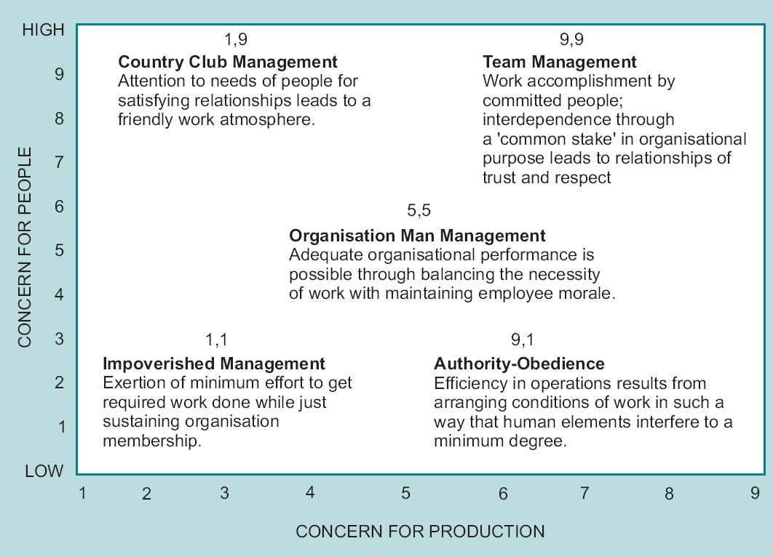

Thanks and Revision History
The material in this document is obviously reproduced from the Organizational Behavior course text of the Edinburgh Business School. It was intended to aid me in understanding the course content, prepare for the exam, and serve as future reference. I have included in various places material from past exam questions as well as comments from fellow students that answered my questions on the “Watercooler” (http://forums.delphiforums.com/hwmba/start). Many thanks to those who make the “Watercooler” an invaluable study help. For this course summary I would like to especially say thank you to Irene Gelyk, who helped me out when I lost a chapter and a half of the black book when traveling. If you find any errors, omissions or have any other suggestions for improvement, please don’t hesitate to contact me at delingat@yahoo.com. If you just want to know who I am feel free to check out http://www.geocities.com/delingat.



Marc

Revision History
Version 1.0 on May 21, 2003

